# Postman: Assignment 1: Activities



### Collection 1: Assignment1_Activities (Normal)



Method used: Get, Post, Put and Delete



### Collection 2: Assignment1_ActivitiesUrl (Added URL in the environment)

Method used: Get, Post, Put and Delete

Environment:

### Collection 3: Assignment1_ActivitiesFolderwithdata (here used folder with data in postman collection)

Method used: Post and Put

### Collection 4: Assignment1_ActivitiesUrlFolder (DataDriven)

Method used: Post and Put

Response:

# Postman: Assignment 2: Authors

### Collection 1: Assignment2_Authors (Normal)

Method used: Get, Post, Put and Delete

### Collection 2: Assignment2_AuthorsUrl (with data driven and folder)

Method used: Get, Post, Put and Delete

# Newman: Assignment 1: Activities:



Commands:

1. newman run C:\Users\0044AQ744\Desktop\AB\Assignment1_Activities.postman_collection.json

**And**

newman run C:\Users\0044AQ744\Desktop\AB\Assignment1_Activities.postman_collection.json -r html

Reports path: file:///C:/Users/0044AQ744/newman/newman-run-report-2024-02-07-09-23-56-899-0.html

1. newman run C:\Users\0044AQ744\Desktop\AB\Assignment1_Activities.postman_collection.json -n 3

**And**

newman run C:\Users\0044AQ744\Desktop\AB\Assignment1_Activities.postman_collection.json -n 3 -r html

Report:

1. newman run "C:\Users\0044AQ744\Desktop\AB\Assignment1_ActivitiesUrlFolder.postman_collection.json" -e "C:\Users\0044AQ744\Desktop\AB\Activities.postman_environment.json" -d "C:\Users\0044AQ744\Desktop\AB\ActivitiesPost1.json"

**And**

newman run "C:\Users\0044AQ744\Desktop\AB\Assignment1_ActivitiesUrlFolder.postman_collection.json" -e "C:\Users\0044AQ744\Desktop\AB\Activities.postman_environment.json" -d "C:\Users\0044AQ744\Desktop\AB\ActivitiesPost1.json" -r html

Report:

1. newman run "C:\Users\0044AQ744\Desktop\AB\Assignment1_ActivitiesUrlFolder.postman_collection.json" -e "C:\Users\0044AQ744\Desktop\AB\Activities.postman_environment.json" -d "C:\Users\0044AQ744\Desktop\AB\ActivitiesPost1.json" --folder PostActivities

**And**

newman run "C:\Users\0044AQ744\Desktop\AB\Assignment1_ActivitiesUrlFolder.postman_collection.json" -e "C:\Users\0044AQ744\Desktop\AB\Activities.postman_environment.json" -d "C:\Users\0044AQ744\Desktop\AB\ActivitiesPost1.json" --folder PostActivities -r html

Report:

# Newman: Assignment 2: Authors

Commands:

newman run C:\Users\0044AQ744\Desktop\AB\API\Assignment2_Authors.postman_collection.json

**And**

newman run C:\Users\0044AQ744\Desktop\AB\API\Assignment2_Authors.postman_collection.json -r html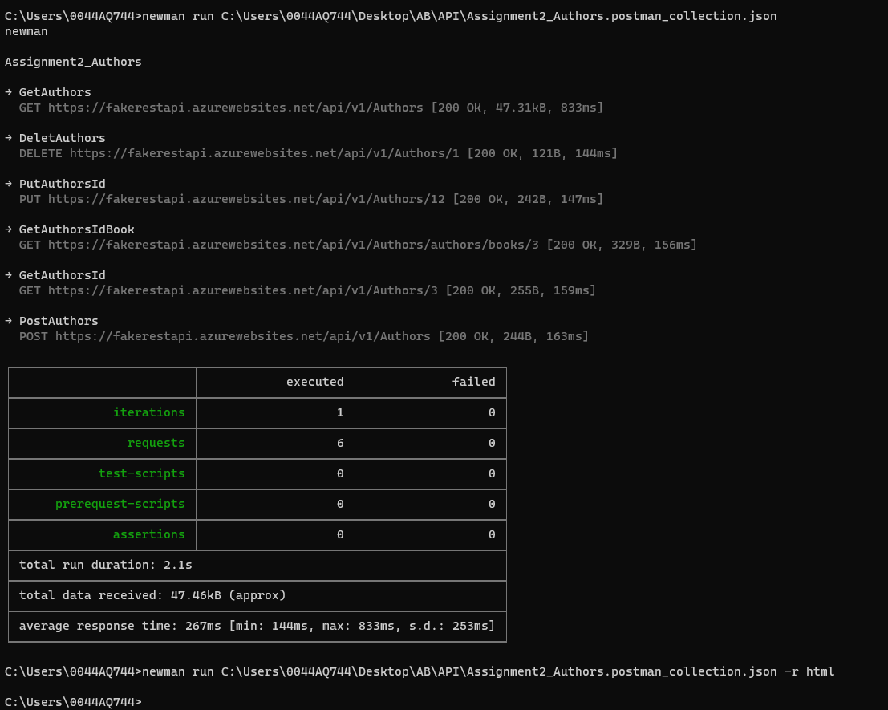

Report:

2.

newman run C:\Users\0044AQ744\Desktop\AB\API\Assignment2_Authors.postman_collection.json -n 2

**And**

newman run C:\Users\0044AQ744\Desktop\AB\API\Assignment2_Authors.postman_collection.json -n 2 -r html

Report:

3.

newman run "C:\Users\0044AQ744\Desktop\AB\API\Assignment2_AuthorsUrl.postman_collection.json" -e "C:\Users\0044AQ744\Desktop\AB\API\Activities.postman_environment.json" -d "C:\Users\0044AQ744\Desktop\AB\API\AuthorsPost.json"

**And**

newman run "C:\Users\0044AQ744\Desktop\AB\API\Assignment2_AuthorsUrl.postman_collection.json" -e "C:\Users\0044AQ744\Desktop\AB\API\Activities.postman_environment.json" -d "C:\Users\0044AQ744\Desktop\AB\API\AuthorsPost.json" -r html

Report:

4.

newman run "C:\Users\0044AQ744\Desktop\AB\API\Assignment2_AuthorsUrl.postman_collection.json" -e "C:\Users\0044AQ744\Desktop\AB\API\Activities.postman_environment.json" -d "C:\Users\0044AQ744\Desktop\AB\API\AuthorsPost.json" --folder Post

**And**

newman run "C:\Users\0044AQ744\Desktop\AB\API\Assignment2_AuthorsUrl.postman_collection.json" -e "C:\Users\0044AQ744\Desktop\AB\API\Activities.postman_environment.json" -d "C:\Users\0044AQ744\Desktop\AB\API\AuthorsPost.json" --folder Post -r html

Report:

# Jira

Jira Defect:

**Description:** Once run the Delete method the id should be deleted and should not be present in Get method but after running the Get method the deleted id is getting displayed in body.

**Steps to reproduce:**

1. Go to Postman
2. Run Get method with id {2} (Get: <https://fakerestapi.azurewebsites.net/api/v1/Activities/2>)
3. Status code 200 will be displayed after running Get.
4. Run Delete method with id {2} (Delete: <https://fakerestapi.azurewebsites.net/api/v1/Activities/2>)
5. Status code 200 will be displayed after running Delete.
6. Recheck if id{2} is present or not in Get,

**Expected Result:** Id{2} should not be found in the Get method

**Actual Result:** Id{2} is present in Get method.

**Screenshot:** Please refer attachment

# Github:

Please find all files in below path. I have used Shireesha username and password.

**Path:** https://github.com/Shireeshaibm/AB_API.git

